**Asiqul Hoque**

**Section 5 Lesson 1: Using GROUP BY and HAVING Clauses**

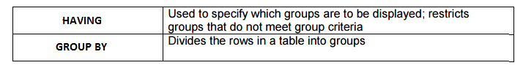

**1. In the SQL query shown below, which of the following is true about this query?**

**__T_____ a. Kimberly Grant would not appear in the results set.**

**___F____ b. The GROUP BY clause has an error because the manager_id is not listed in**

**the SELECT clause.**

**___T____ c. Only salaries greater than 16001 will be in the result set.**

**___T____ d. Names beginning with Ki will appear after names beginning with Ko.**

**___F____ e. Last names such as King and Kochhar will be returned even if they don’t**

**have salaries > 16000.**

**SELECT last_name, MAX(salary)**

**FROM employees**

**WHERE last_name LIKE 'K%'**

**GROUP BY manager_id, last_name**

**HAVING MAX(salary) >16000**

**ORDER BY last_name DESC ;**

**2A. SELECT manager_id**

**FROM employees**

**WHERE salary < 16000**

**GROUP BY manager_id;**

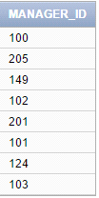

**2B. SELECT COUNT(title)**

**FROM d_cds**

**WHERE cd_number < 93;**



**2C. SELECT MAX(ID), artist AS Artist**

**FROM d_songs**

**WHERE duration IN('3 min', '6 min', '10 min')**

**HAVING MAX(ID)<50**

**GROUP BY ARTIST;**

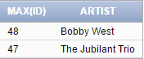

**2D. SELECT loc_type, rental_fee AS Fee**

**FROM d_venues**

**WHERE id <100**

**GROUP BY rental_fee,loc_type;**

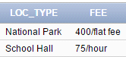

**3. SELECT MAX(DISTINCT song_id)**

**FROM d_track_listings**

**WHERE track IN ( 1, 2, 3);**



**4. Indicate True or False**

**___T__ a. If you include a group function and any other individual columns in a SELECT**

**clause, then each individual column must also appear in the GROUP BY**

**clause.**

**__F___ b. You can use a column alias in the GROUP BY clause.**

**__T___ c. The GROUP BY clause always includes a group function.**

**5.Write a query that will return both the maximum and minimum average salary grouped by**

**department from the employees table.**

SELECT ROUND(MAX(AVG(SALARY))), MIN(AVG(SALARY))

FROM employees

GROUP by department_id;



**6. SELECT AVG(MAX(salary)) As "Maximum Average Salary"**

**FROM EMPLOYEES**

**GROUP BY DEPARTMENT_ID;**

